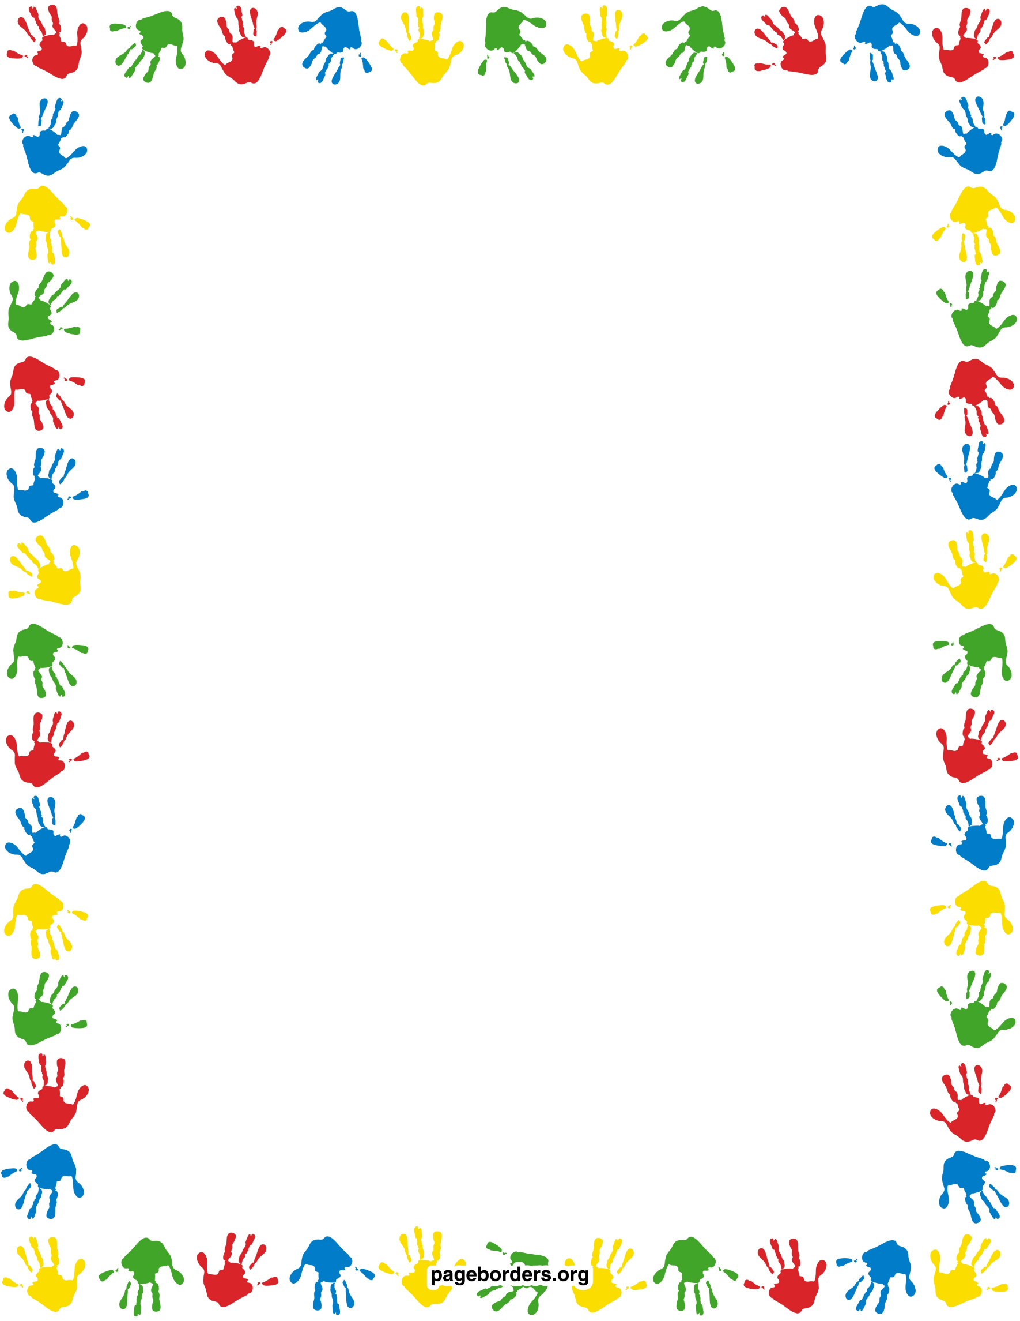

RULES

Be nice

Listen to the teacher

Have fun

UH-OH

Reminder

Time-out

Talk to mom or dad