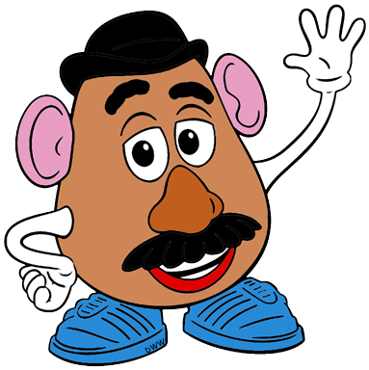

4. Raise your hand to talk.

5. Smile, sing and say nice things.

6. Keep your feet on the floor.

3. Keep your hands to yourself.

2. Use your listening ears.

1. Keep your eyes on the teacher.

**PRESCHOOL**

**CLASS RULES**